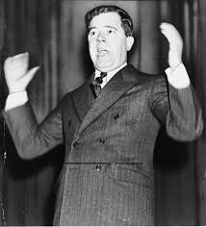

I was disappointed by the slow pace of reform and in 1934 I established the ‘Share Our Wealth Society’. I promised every family an allowance of $5000 and a minimum income of $2500. This was to be paid for by taxation of the rich and the confiscation of fortunes over $5 million.

We opposed FDR by ruling some of his measures unconstitutional because we felt they infringed on states’ rights and contravened the constitution.



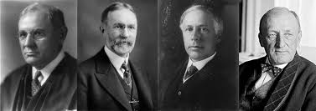

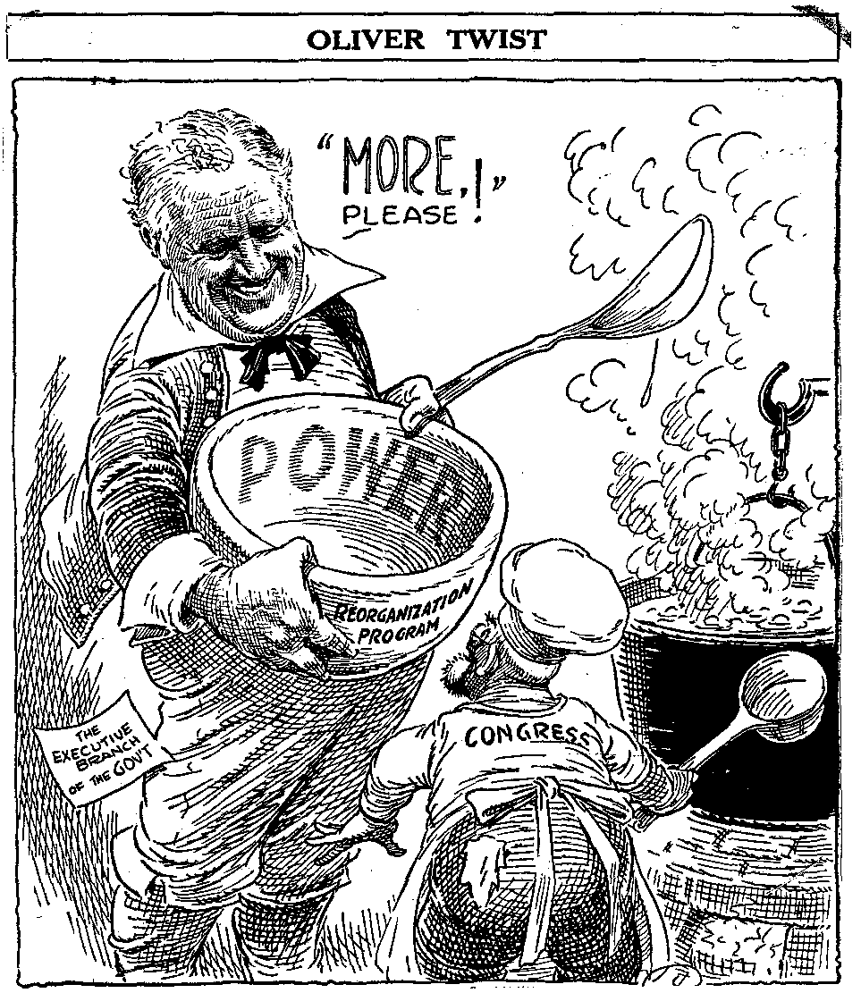

We believed in ‘laissez-faire’ policies. We opposed tax payers’ money being used to help the poor and unemployed.

**Political Opposition**

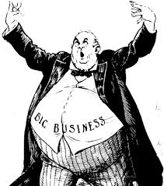

Big business opposed FDR because we felt threatened by government regulation and the rise of the unions. We campaigned against the Public Utility Holding Act and the Wagner Act